**Online Quiz Application**

**Screenshots**

**Json data format example**

**Index.html**

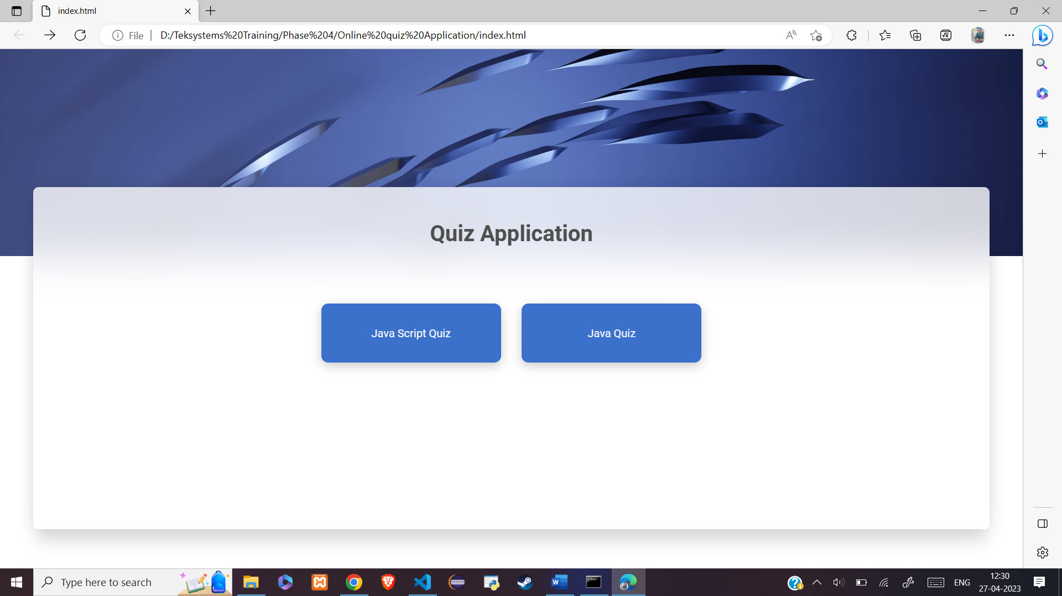

**Quiz.html(Java quiz)**

**Review Part**

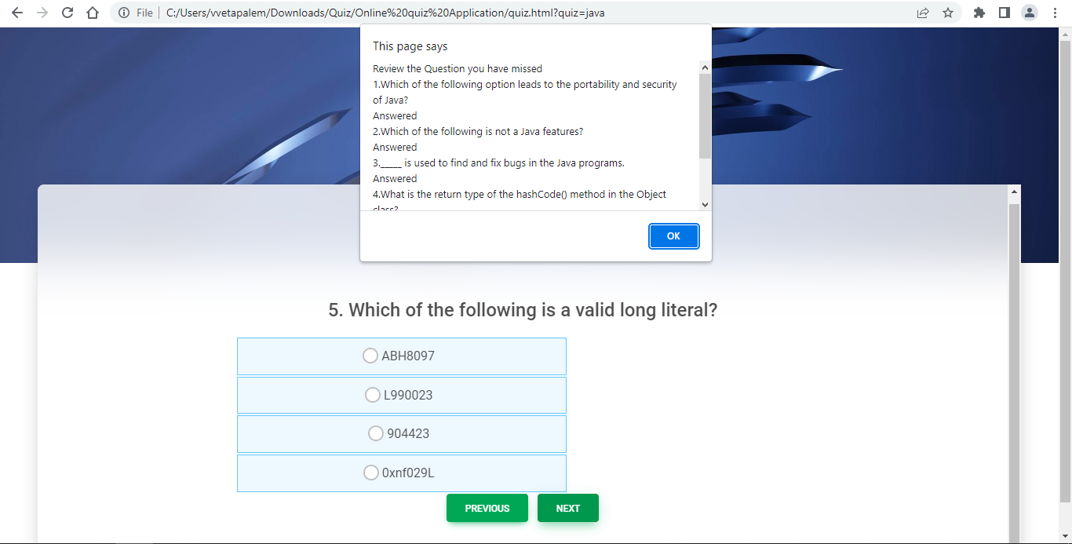

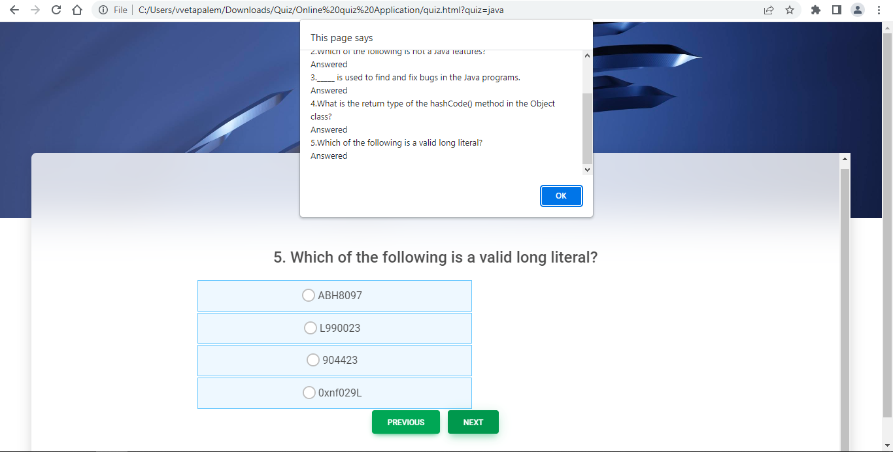

**

**

**Results part**

